NAME : NAVODITAA A.R
ROLL NO.:241901071

Exercise 3

UDP CLIENT-SERVER COMMUNICATION USING SOCKET PROGRAMMING IN PYTHON
INTRODUCTION:
UDP (User Datagram Protocol) is a connectionless protocol that allows sending messages (datagrams) between client and server without establishing a connection. This experiment demonstrates a simple UDP client-server communication in Python.
AIM:
Develop a simple UDP server and client using Python’s socket module to exchange messages.
ALGORITHM:
SERVER:
- Create a UDP socket and bind it to an IP and port.
- Wait for incoming messages.
- Receive data, print it, and optionally send a reply.
CLIENT:
- Create a UDP socket.
- Send message to server IP and port.
- Receive reply from server and display it.

CODE:
SERVER:
import socket
sockfd = socket.socket(socket.AF_INET, socket.SOCK_DGRAM)
print('UDP Socket Created')
sockfd.bind(('localhost', 55555))
print('Waiting for messages')
while True:
data, addr = sockfd.recvfrom(1024)
receivedMsg = data.decode()
print("Received message from", addr)
print("Message:", receivedMsg)
# Send the same message back to client
sockfd.sendto(data, addr)
print("Message reply sent to Client!")
choice = input("Do you want to continue (type y or n): ")
if choice == 'n':
break
sockfd.close()

CLIENT:
import socket
clientfd = socket.socket(socket.AF_INET, socket.SOCK_DGRAM)
server_address = ('localhost', 55555)
name = input("Enter your message: ")
clientfd.sendto(name.encode(), server_address)
data, _ = clientfd.recvfrom(1024)
print("Message Received from Server:", data.decode())
clientfd.close()

OUTPUT:
SERVER:
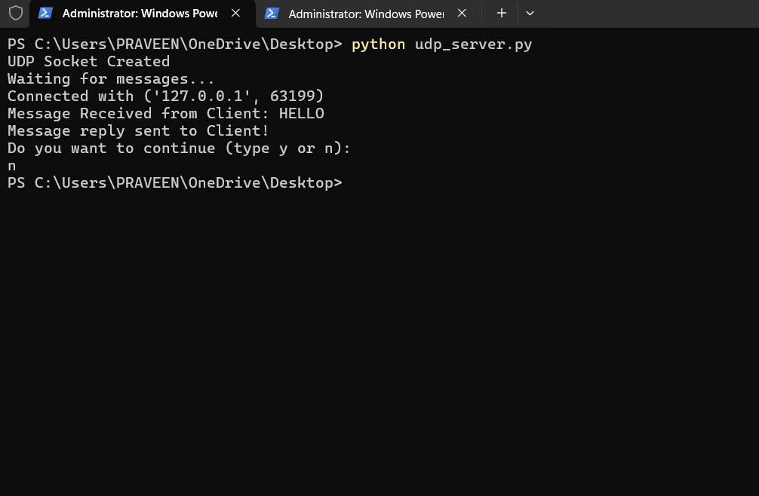

CLIENT:
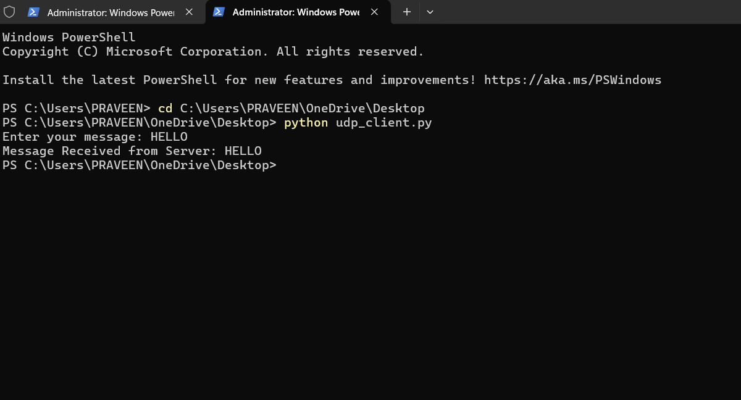

RESULT:
The UDP client successfully sent messages to the server, and the server received and replied to each message.

